# **Selection filter result based on aggregate or detail level**

## **Scenarios in details:**

### **Reference level is detail level nodes:**

#### **Selection created only by dimension:**

##### **Configuration:**

Aggregation by default: blank (detail level nodes)

Selection: based on product dimension key (*Rule: ‘SELECTION1’*)

Sort sequence: product level 2 and 1 (*Line analyzer template:* *‘Selection’*)

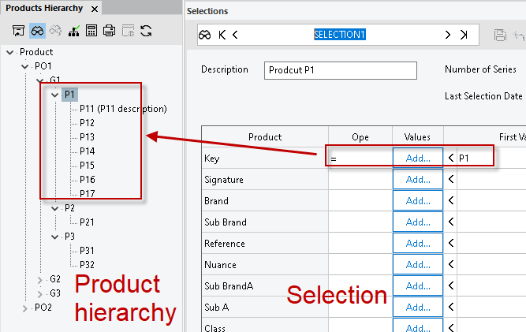

##### **Result:**

Only node under P1 will be shown in the result, sort sequence is built based on filtered nodes

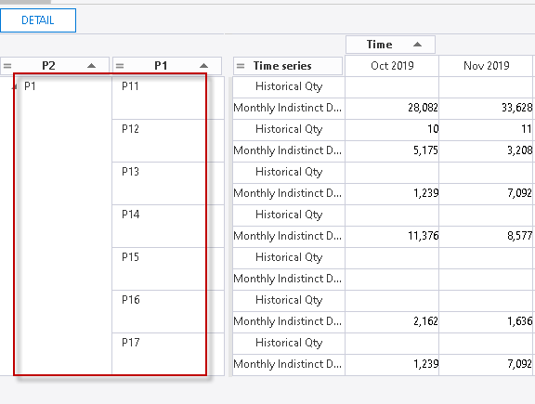

#### **Selection created with both dimension and attribute:**

##### **Configuration:**

Aggregation by default: blank (detail level nodes)

Selection: based on product dimension key and product attribute 2 group level 2 (*Rule: ‘SELECTION2’*)

Sort sequence: product level 2 and 1 (*Line analyzer template:* *‘Selectio2’*)

Attribute configuration for product level 2:

|  |  |
| --- | --- |
| **Product** | **Attribute 2** |
| P11 | P201 |
| P12 | P202 |
| P13 | P203 |
| P14 |  |
| P15 |  |
| P16 |  |
| P17 |  |

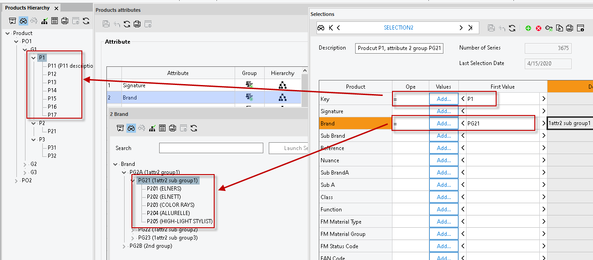

##### **Result:**

The filter result is the combination of dimension and attribute, so only node of product under P1 and applied with attribute 2 under group PG21 will be displayed in the result.

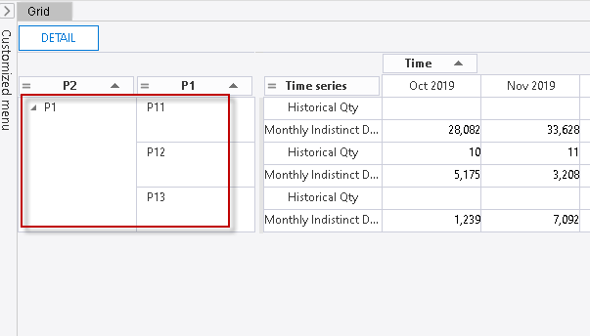

### **Reference level is aggregate level nodes:**

#### **Selection created only by dimension:**

##### **Aggregation rule only based on dimension, for the same dimension used when selection level>aggregation level ,**

For example, aggregation rule is based on product level 1, but the selection used product key of level 2

###### **Configuration:**

Aggregation rule: created based on product dimension level 1, sales territory level 2 (*Rule name: ‘P1S2’*)

Selection: based on product dimension key of level 2 (*Rule: ‘SELECTION1’*)

Sort sequence: product level 2 and 1 (*Line analyzer template:* *‘Selection3’*)

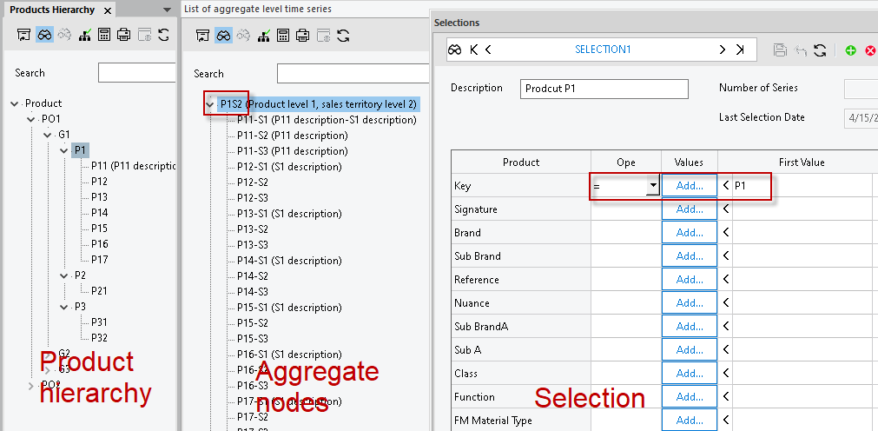

###### **Result:**

Only aggregate created with dimension value under selection dimension key will be shown in the result, sort sequence is built based on filtered nodes

So in this case, only nodes for product under P1 will be filtered outs

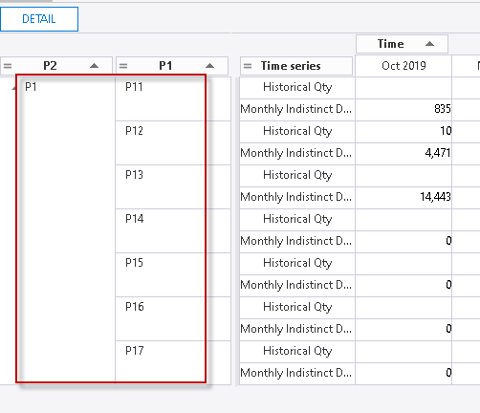

##### **Aggregation rule only based on dimension, for the same dimension used when selection level=aggregation level**

For example, aggregation rule is based on product level 2, and the selection alse used product key of level 2

###### **Configuration:**

Aggregation rule: created based on product dimension level 2, sales territory level 2 (*Rule name: ‘P2S2’*)

Selection: based on product dimension key of level 2 (*Rule: ‘SELECTION1’*)

Sort sequence: product level 2 and 1 (*Line analyzer template:* *‘Selection4’*)

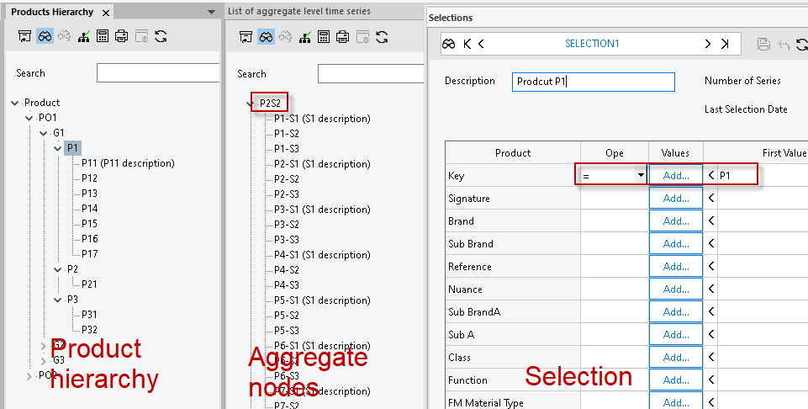

###### **Result:**

As the selection key used is the same level as the aggregation dimension, so only aggregate create with dimension equals to selection dimension key will be shown in the result, sort sequence is built based on filtered nodes.

So in this case, only nodes for product P1 will be filtered out.

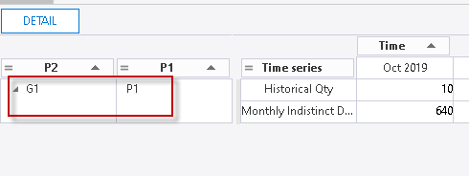

##### **Aggregation rule only based on dimension, for the same dimension used when selection level<aggregation level**

For example, aggregation rule is based on product level 3, but the selection used product key of level 2

###### **Configuration:**

Aggregation rule: created based on product dimension level 3, sales territory level 2 (*Rule name: ‘P3S2’*)

Selection: based on product dimension key of level 2 (*Rule: ‘SELECTION1’*)

Sort sequence: product level 2 and 1 (*Line analyzer template:* *‘Selection5’*)

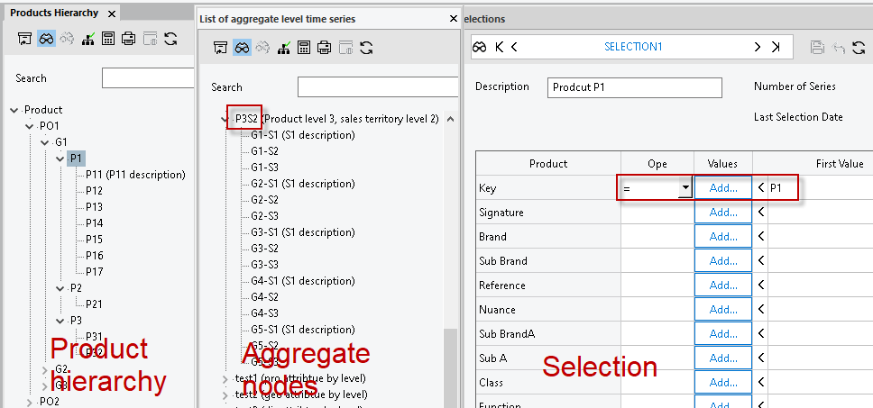

###### **Result:**

As the selection dimension used is lower than the aggregation dimension. So in this case we use the lower dimension to filter the higher one, and as can’t get any nodes.

And the result is no record filtered out.

##### **Aggregation rule only based on dimension&attribute= level 1**

###### **Configuration:**

Aggregation rule: created based on product and sales territory dimension level 1, product attribute 6 level 1, sales territory attribute 3 level 1 (*Rule name: ‘P1-Atr6L1-S1-Atr3L1’*)

Selection: based on product and sales territory dimension key of level 2 (*Rule: ‘SELECTION3’*)

Sort sequence: level 2 and 1 for: product, sales territory, product attribute 6 and sales territory attribute 3 (*Line analyzer template:* *‘Selection6’*)

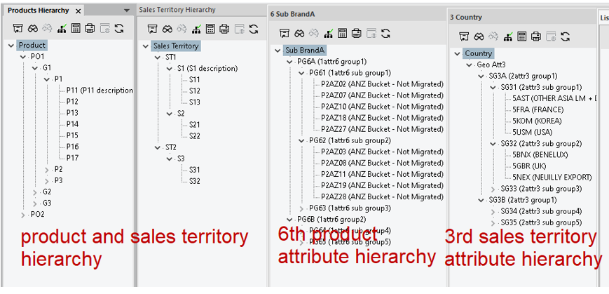

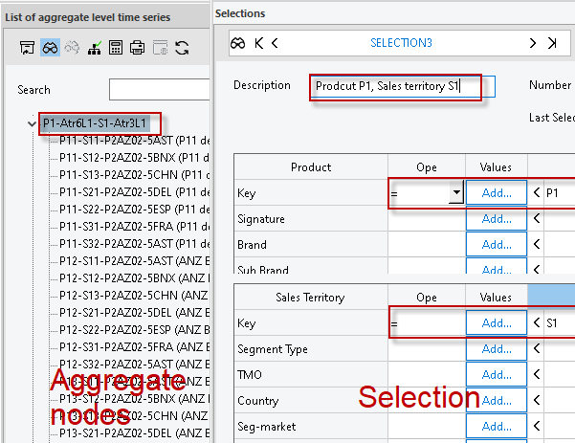

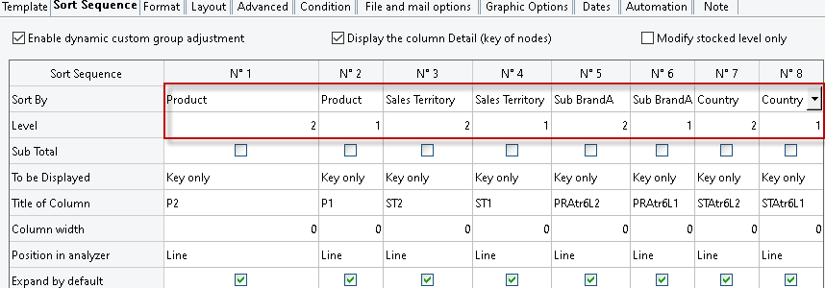

###### **Result:**

As the selection condition is based on the same dimension level with the aggregation, so the selection filter is done based on the corresponding dimension, only key meet condition will be filtered out.

Here selection condition ‘P1’ will do filter on product level 1 in aggregation rule, and sales territory condition ‘S1’ will do filter on sales territory level 1 in aggregation rule.

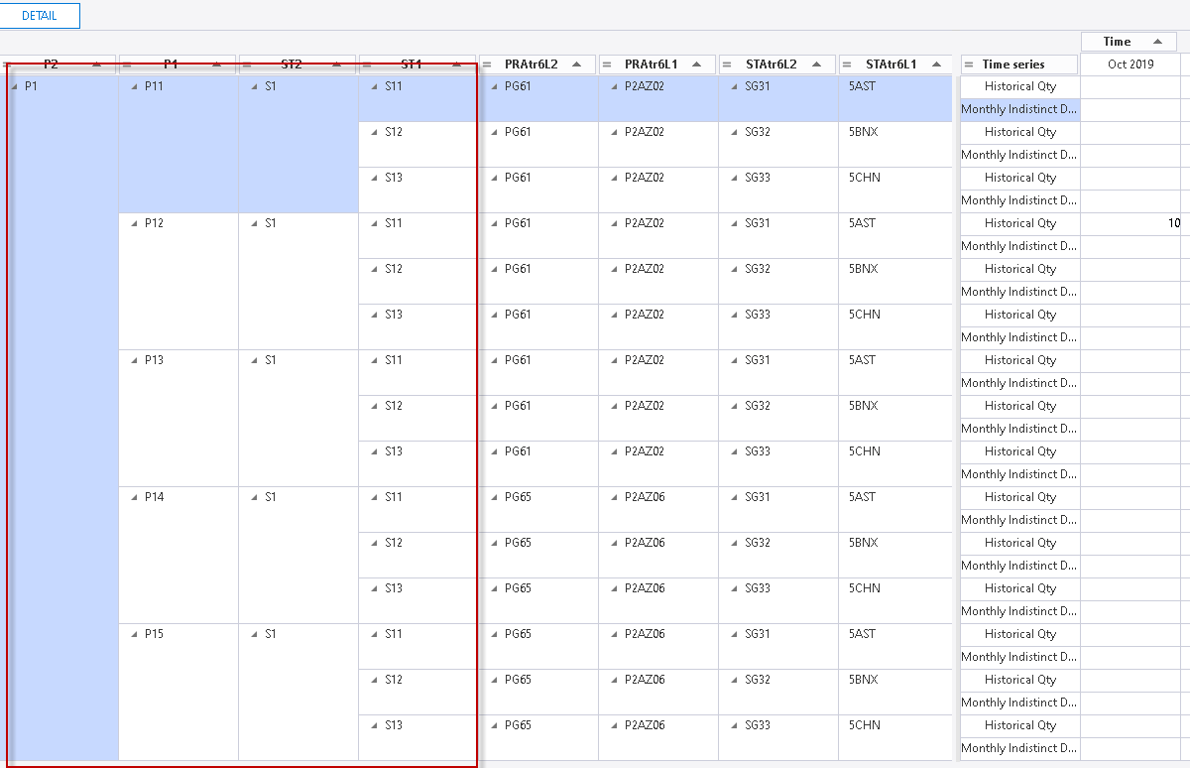

##### **Aggregation rule only based on dimension&attribute> level 1**

###### **Configuration:**

Aggregation rule: created based on product and sales territory dimension level 2, product attribute 6 level 2, sales territory attribute 3 level 2 (*Rule name: ‘P2-Atr6L2-S2-Atr3L2’*)

Selection: based on product and sales territory dimension key of level 3 (*Rule: ‘SELECTION4’*)

Sort sequence: level 2 and 1 for: product, sales territory, product attribute 6 and sales territory attribute 3 (*Line analyzer template:* *‘Selection7’*)



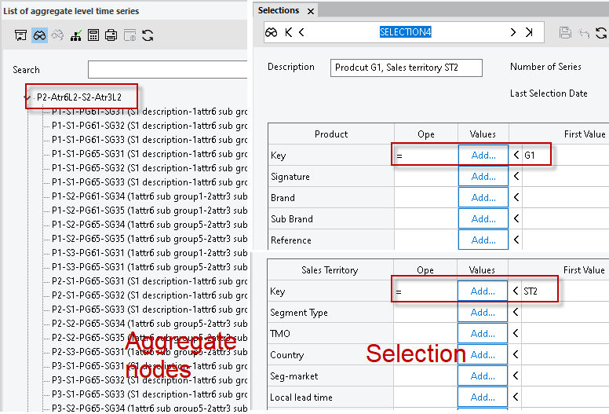

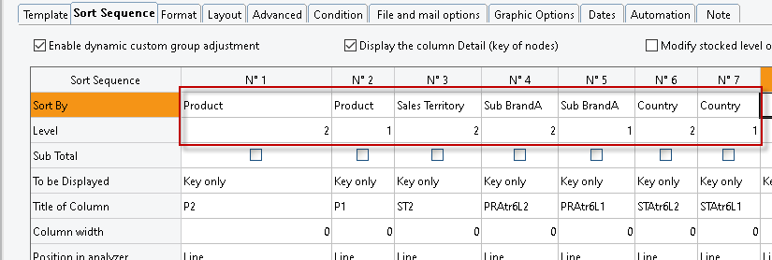

###### **Result:**

As the selection condition is based on the dimension level, so the selection filter is done based on the corresponding dimension, only key meet condition will be filtered out.

Her selection condition ‘G1’ will do filter on product level 2 in aggregation rule, and sales territory condition ‘ST2’ will do filter on sales territory level 2 in aggregation rule.

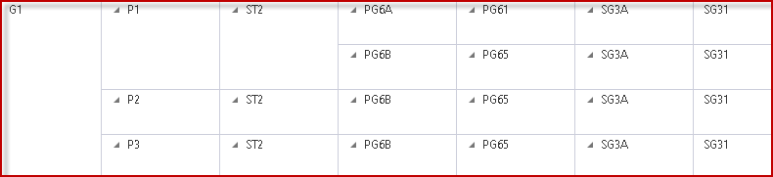

#### **Selection created only by both dimension and attribute:**

##### **Aggregation rule only based on dimension**

###### **Configuration:**

Aggregation rule: created based on product dimension level 2, sales territory level 2 (*Rule name: ‘P2S2’*)

Selection: based on product dimension key of level 3, product attribute 2 level 2 group, sales territory dimension key of level 3, sales territory attribute 1 level 2 group (*Rule: ‘SELECTION6’*)

Sort sequence: product level and sales territory 2 and 1 (*Line analyzer template:* *‘Selection8’*)

Attribute configuration for both product and sales territory of level 2 :

|  |  |
| --- | --- |
| **Product** | **Attribute 2** |
| P1 | P201 |
| P2 | P207 |
| P3 | P210 |

|  |  |
| --- | --- |
| **Sales territory** | **Attribute 1** |
| P1 | AD |
| S2 | RE |

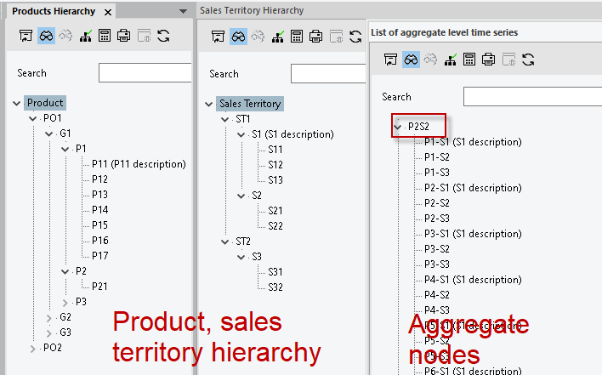

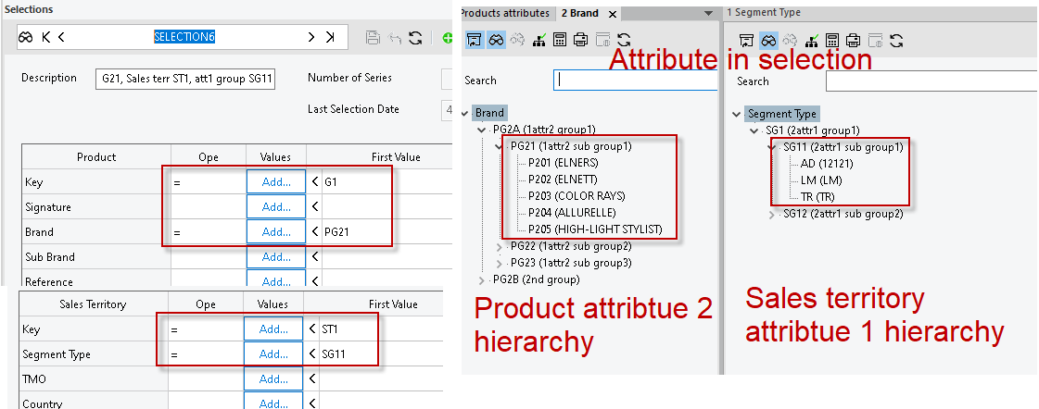

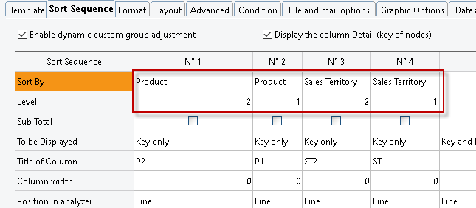

###### **Result:**

The result is the combination of dimension and attribute filter applied on the specified level directly

For product group level 2, first only value under G1 is filtered out then filtered by the attribute under group PG21, so only P1 meet the condition.

For sales territory level 2, first only value under ST1 is filtered out then filtered by the attribute under group S121, so only S1 meet the condition.

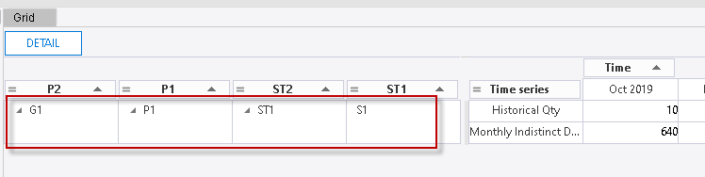

##### **Aggregation rule only based on dimension and attribute=level1, aggregation attribute differ from selection attribute**

###### **Configuration:**

Aggregation rule: created based on product and sales territory dimension level 1, product attribute 6 level 1, sales territory attribute 3 level 1 (*Rule name: ‘P1-Atr6L1-S1-Atr3L1’*)

Selection: based on product dimension key of level 2, product attribute 2 level 2 group, sales territory dimension key of level 2, sales territory attribute 1 level 2 group (*Rule: ‘SELECTION5’*)

Sort sequence: product level and sales territory 2 and 1, product attribute 6 and sales territory attribute 3 level 1 (*Line analyzer template:* *‘Selection9’*)

|  |  |  |
| --- | --- | --- |
| **Product** | **Attribute 2** | **Attribute group** |
| P11 | P201 | PG21 |
| P12 | P202 | PG21 |
| P13 | P203 | PG21 |
| P14 | P207 | PG22 |
| P15 | P206 | PG22 |
| P16 |  |  |
| P17 |  |  |

|  |  |  |
| --- | --- | --- |
| **Sales territory** | **Attribute 1** | **Attribute group** |
| S11 | AD | SG11 |
| S12 | LM | SG11 |
| S13 | EC | SG12 |

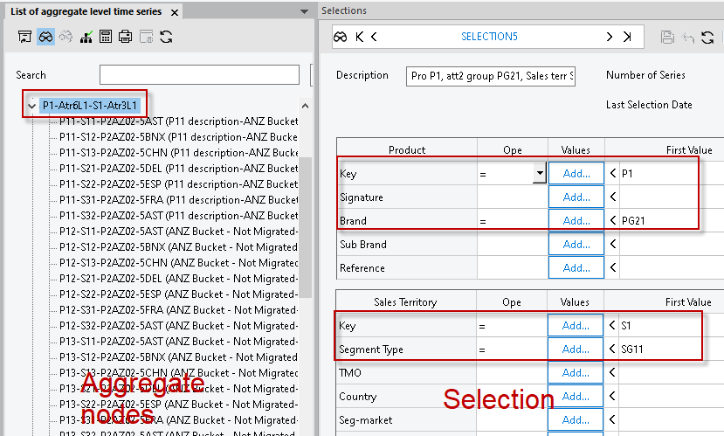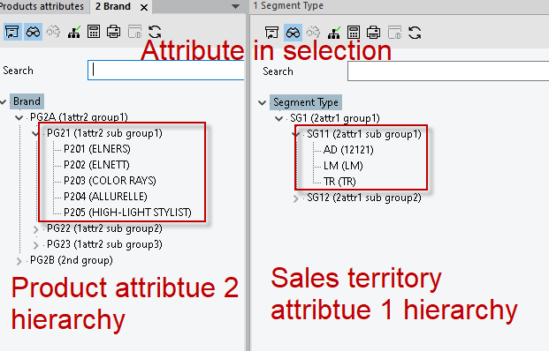

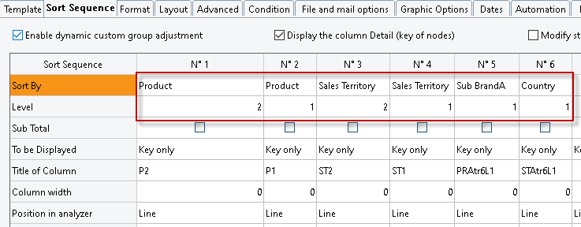

###### **Result:**

As the aggregation rule is built on level 1, so the filter by both dimension and attribute condition will be done on dimension hierarchy level 1 for the aggregation.

In this case for product dimension here, dimension condition ‘P1’ and attribute 2 condition PG21 will do filter on product level 1 in aggregation rule, so only P11, P12 and P13 will be filtered out.

Sales territory condition ‘S1’ and attribute 1 condition SG11 will do filter on sales territory level 1 in aggregation rule, so only S11 and S12 will be filtered out.

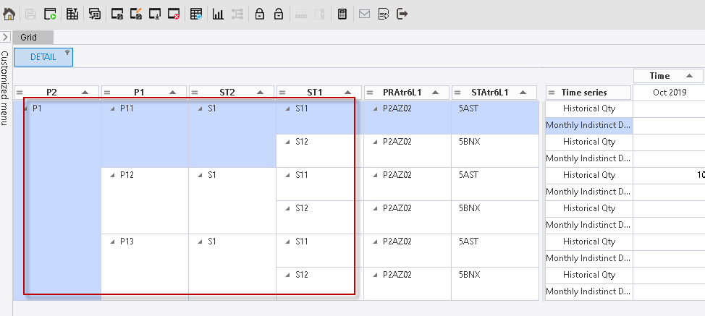

##### **Aggregation rule only based on dimension and attribute>level1, aggregation attribute differ from selection attribute**

###### **Configuration:**

Aggregation rule: created based on product and sales territory dimension level 1, product attribute 6 level 1, sales territory attribute 3 level 1 (*Rule name: ‘P2-Atr6L2-S2-Atr3L2’*)

Selection: based on product dimension key of level 2, product attribute 2 level 2 group, sales territory dimension key of level 2, sales territory attribute 1 level 2 group(*Rule: ‘SELECTION6’*)

Sort sequence: product level 2 and 1, sales territory level 2, product attribute 6 and sales territory attribute 3 level 2 and 1. (*Line analyzer template:* *‘Selection10’*)

Attribute configuration for both product and sales territory of level 2 :

|  |  |  |
| --- | --- | --- |
| **Product** | **Attribute 2** | **Attribute group** |
| P1 | P201 | PG21 |
| P2 | P207 | PG22 |
| P3 | P210 | PG21 |

|  |  |  |  |
| --- | --- | --- | --- |
| **Sales territory** | **Attribute 1** |  | **Attribute group** |
| S1 | AD |  | SG11 |
| S2 | RE |  | SG12 |

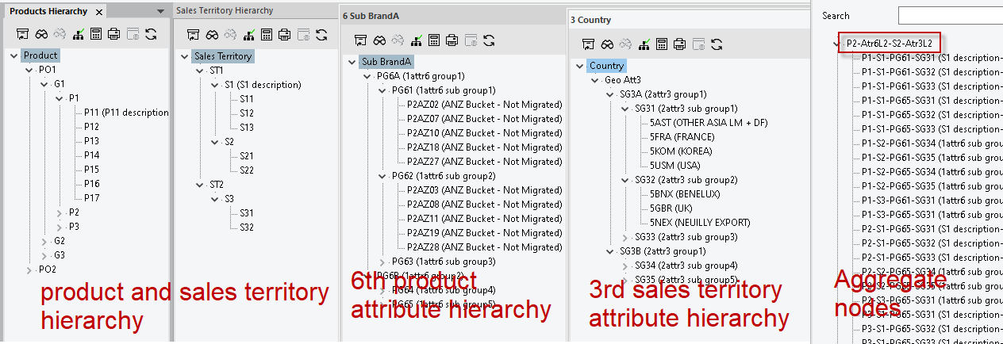

 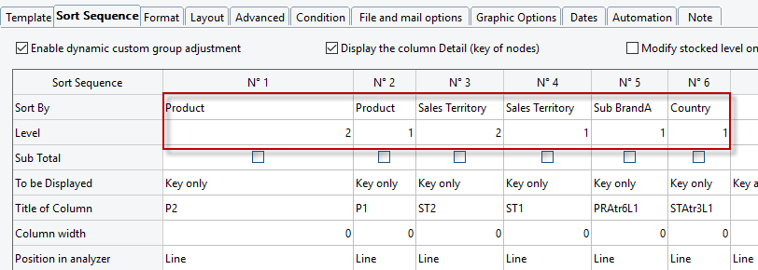

###### **Result:**

The result is the combination of dimension and attribute filter applied on the specified level directly

For product group level 2, first only value under G1 is filtered out then filtered by the attribute under group PG21, so only P1 meet the condition.

For sales territory level 2, first only value under ST1 is filtered out then filtered by the attribute under group S121, so only S1 meet the condition.

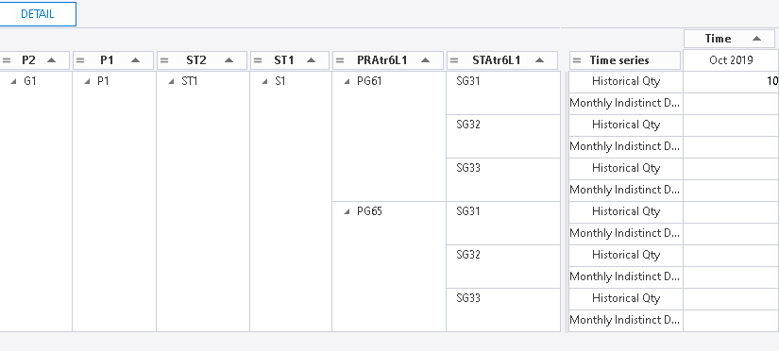

##### **Aggregation rule only based on dimension and attribute>level1, aggregation attribute same as selection attribute**

###### **Configuration:**

Aggregation rule: created based on product and sales territory dimension level 1, product attribute 6 level 1, sales territory attribute 3 level 1 (*Rule name: ‘P2-Atr6L2-S2-Atr3L2’*)

Selection: based on product dimension key of level 2, product attribute 2 level 2 group, sales territory dimension key of level 2, sales territory attribute 1 level 2 group(*Rule: ‘**SELECTION7’*)

Sort sequence: product level 2 and 1, sales territory level 2, product attribute 6 and sales territory attribute 3 level 2 and 1. (*Line analyzer template:* *‘Selection11’*)

Attribute configuration for both product and sales territory of level 2 :

|  |  |  |
| --- | --- | --- |
| **Product** | **Attribute 6** | **Attribute group** |
| P1 | P2AZ02 | PG61 |
| P2 | P2AZ03 | PG62 |
| P3 | P2AZ05 | PG64 |

|  |  |  |
| --- | --- | --- |
| **Sales territory** | **Attribute 3** | **Attribute group** |
| S1 | 5GBR | SG32 |
| S2 | 5DEL | SG34 |

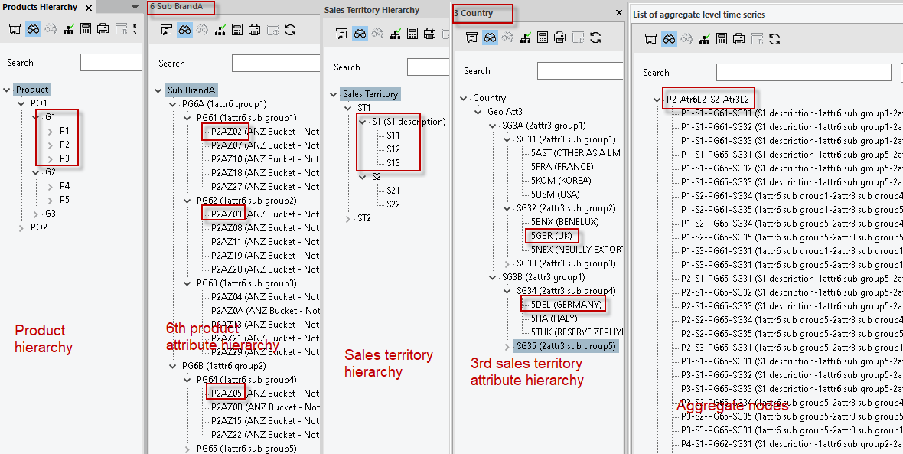

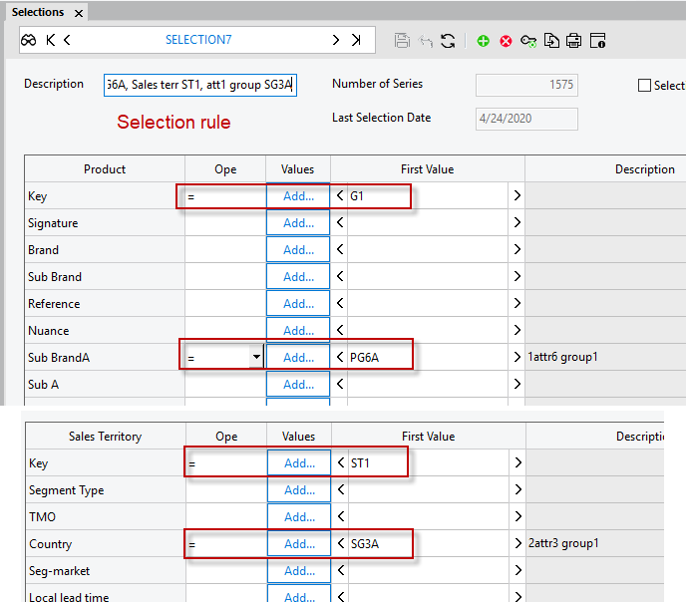

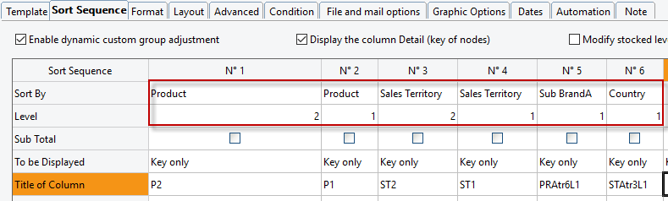

###### **Result:**

The result is the combination of dimension and attribute filter applied on the specified dimension and attribute level directly.

* For product group level 2, both dimension and attribute condition in selection definition will be applied. First only value under G1 is filtered out, then filtered by the attribute under group PG6A, and P1 and P2 meet the condition.
* For 6th product attribute level 2, based on the attribute condition PG6A, so PG61, PG62 and PG63 meet the condition
* For sales territory level 2, both dimension and attribute condition in selection definition will be applied. First only value under ST1 is filtered out, then filtered by the attribute under group SG3A, so only S1 meet the condition.
* For 3rd sales territory attribute level 2, based on the attribute condition SG3A, so SG31, SG32 and SG33meet the condition

Combined with those conditions below nodes should be filtered out:

|  |  |  |  |
| --- | --- | --- | --- |
| Product | 6th attribute | Sales territory | 3rd attribute |
| P1  P2 | PG1  PG2  PG3 | S1 | SG1  SG2  SG3 |

Considering the node list in this aggregation rule, only 3 nodes meet the condition: P1-S1-PG61-SG31, P1-S1-PG61-SG32, P1-S1-PG61-SG33

